**YEAR 12 PHYSICS 2019**

**TEST 5: POWER GENERATION, WAVES AND QUANTA**

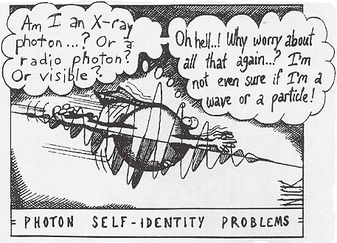

**NAME**:  **SOLUTIONS**

**MARKS**:  **/50**

**Instructions:**

1. Do not turn this paper over until you are told to do so.
2. Answer **all** the questions in the spaces provided.
3. Where appropriate, for numerical answers express your answers correct to 3 significant figures.
4. Not all question carry equal number of marks.
5. The marks available for each question are shown.

6. Show working out steps neatly, logically and clearly to score full marks.

7. You can use a scientific calculator.

8. **Write with a blue or black ink pen.** You may use a lead pencil to draw diagrams.

**Question 1**

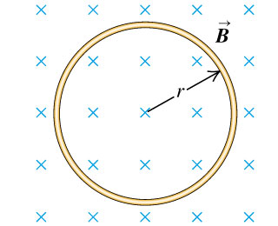The diagram on the right shows a ring of wire of radius r = 2.00 cm, which is fully immersed in a uniform magnetic field B = 50.0 mT. The ring is pulled quickly out of the magnetic field, taking 0.15 s to be clear of the magnetic field.

(a) **Indicate** on the ring the direction of any induced current. (1 mark)

**Clockwise (1)**

(b) If the ring has a resistance of 0.03 Ω, find the size of the average current induced as the ring is pulled clear of the magnetic field. (3 marks)

**  = /t = (0.050 T)(  (0.02m)2 )/(0.15s) (1)**

**= 4.19 x 10-4 V (1)**

**  = /R = (4.19 x 10-4 V)/0.03  = 0.0140 A (1)**

**Question 2**

****Below is a diagram of an AC generator. A coil (UVWX) is 0.300 m by 0.400 m and consists of 20 turns of wire. It is in a uniform magnetic field of strength 0.250 T and can rotate as shown. The coil is rotated at a constant rate of 50 revolutions per secondin the direction shown

(a) What is the maximum emfdeveloped across the resistor R? (2 marks)

**Emax  = 2𝜋NBAf**

**= 2𝜋 x 20 x 0.250 x (0.300 x 0.400) x 50 (1)**

**= 1.88 x 102 V (1)**

(b) Which of the graphs below (**A–D**) best shows the variation of the magnetic fluxthrough the coil as a function of time? Take the direction from N to S in the figure as positive. (1 mark)

**ANSWER**

**B (1)**

(c) Assuming the same conditions as in the question above, which of the above

graphs (**A–D**) best shows the variation of the current flowing **from U to V in the coil**, as a function of time (1 mark)

**ANSWER**

**D (1)**

**Question 3**

Three rings are dropped at the same time over identical magnets as shown below.



Describe the order in which the rings *P*, *Q* and *R* reach the bottom of the magnets.

(2 marks)

P and R arrive at the same time, and first. (1)

Then ring Q. (1)

**Question 4**

A photoelectric cell contains an aluminium electrode that is illuminated with ultraviolet light of wavelength 284 nm. The work function of aluminium is 4.08 eV. Calculate

(a) the energy of one of the ultraviolet photons in electron-volts. (2 marks)

**E = hc/ = (6.63 x 10-34)(3 x 108)/(2.84 x 10-7) (1)**

**= 7.00 x 10-19 J = 4.38 eV (1)**

(b) the velocity of the emitted photo-electrons. (3 marks)

**EK = hf - W = 4.38 eV - 4.08 eV = 0.300 eV (1)**

**∴ EK = 0.300 x 1.6 x 10-19 J**

**= 4.80 x 10-20 J = (1)**

**½ mv2 =**  **4.80 x 10-20**

**½ (9.11 x 10-31) v2 = 4.80 x 10-20**

**v =** **3.25 x 105 m/s (1)**

**Question 5**

A simple transformer is constructed by a group of students to investigate electromagnetic induction. A diagram of the transformer with its attached circuitry is shown below.

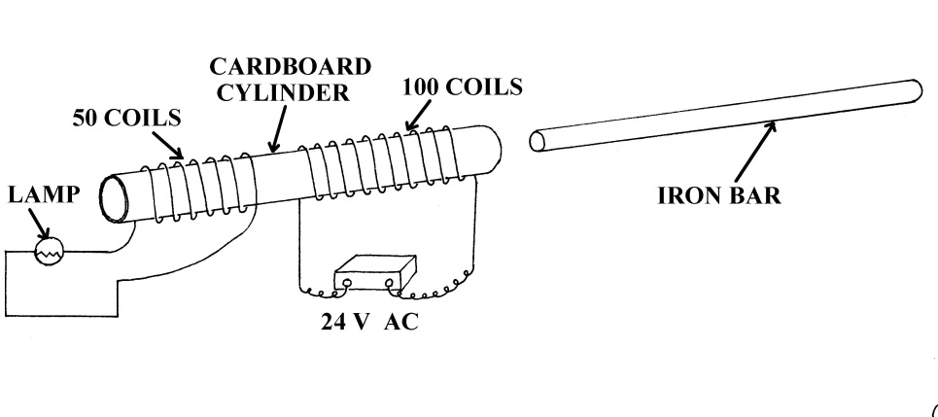

(a) When the 24.0 V AC power supply is switched on the lamp is seen to glow dimly. What causes the lamp to glow? (No calculation required.) (3 marks)

**When the 24 V AC supply is switched on,**

**the 100 turn solenoid experiences an alternating current,**

**and creates a varying/alternating magnetic field. (1)**

**The 50 turn solenoid experiences this varying magnetic field, (1)**

**and by Lenz’s law,**

**induces a current whose magnetic field will oppose the changes.**

**This induced current flows through the globe causing it to glow. (1)**

(b) When the iron bar is inserted into the cardboard tube through both coils the lamp glows brighter. Explain why the lamp now glows brighter than before. (2 marks)

**The iron bar is a ferromagnetic material, which strengthens and**

**directs the magnetic field created by the first solenoid to the second coil. (1)**

**Therefore the second coil experiences a stronger, varying magnetic field,and a larger current is induced to oppose it. (1)**

**The larger current causes the globe to glow more brightly.**

(c) Does the diagram above represent a ‘step up’ or ‘step down’ transformer? Explain your answer. (2 marks)

**Step down, (1)**

**since less turns on the secondary coil with the globe. (1)**

(d) Calculate the theoretical output voltage of the 50 turn coil. (2 marks)

**If the system is 100 % efficient,**

**then $\frac{V_{s}}{V_{p}}=\frac{N_{s}}{N_{p}}$**

**⇒ $V_{s}= \frac{{V_{p} N}_{s}}{N_{p}}= \frac{24 ×50}{100}$ (1)**

**= 1.20 x 101 V** **(1)**

**Question 6**

A laser used in a Compact Disc player emits red light of wavelength 640 nm and is rated at 10.0 mW. Calculate the number of photons hitting the CD every second.

(4 marks)

$E_{photon}=h f= \frac{h c}{}$

$= \frac{6.63 × {10}^{-34} × 3.00 × {10}^{8}}{640 × {10}^{-9}}$**(1)**

**= 3.11 x 10-19 J. (1)**

**Energy every one second = P x 1**

**= 10.0 x 10-3 (1)**

**∴ No. of Photons**

**= 3.22 x 1016. (1)**

**Question 7**

A student carries out an experiment to measure the wavelength of microwave radiation. Microwaves pass through two gaps between metal plates as shown.

As the detector is moved from A to B, a series of maxima and minima are detected. The microwaves passing through the gaps are coherent (in phase).

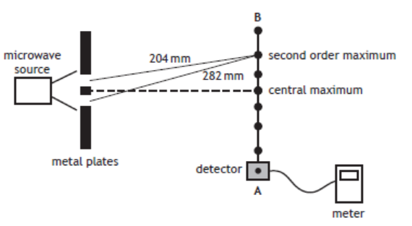

(a) The measurements of the distance from each gap to the second order maximum are shown in the diagram above. Calculate the wavelength of the microwaves. (2 marks)

**Path difference = L2 – L1 = 2 λ**

**i.e. 282 – 204 = 2 λ (1)**

**⇒ λ = 39.0 mm (1)**

**= 3.90 x 10-2 m.**

b) The distance separating the two gaps is now increased. State what happens to the path difference to the second order maximum. Explain your reasoning.

(2 marks)

**No change (1)**

**Since the wavelength does not change. (1)**

**Question 8**

(a) What are the characteristics of an ideal black body? (2 marks)

**A perfect absorber of radiation (1)**

**And a perfect emitter of radiation.**

**OR**

**Radiates and absorbs radiation at the same rate (1)**

(b) A black body radiation curve is shown for an object at 5000 K. Sketch on the graph the curve that would be expected for a 6000 K black body.

(2 marks)

**Higher intensity curve (1)**

**With a smaller minimum wavelength (1)**

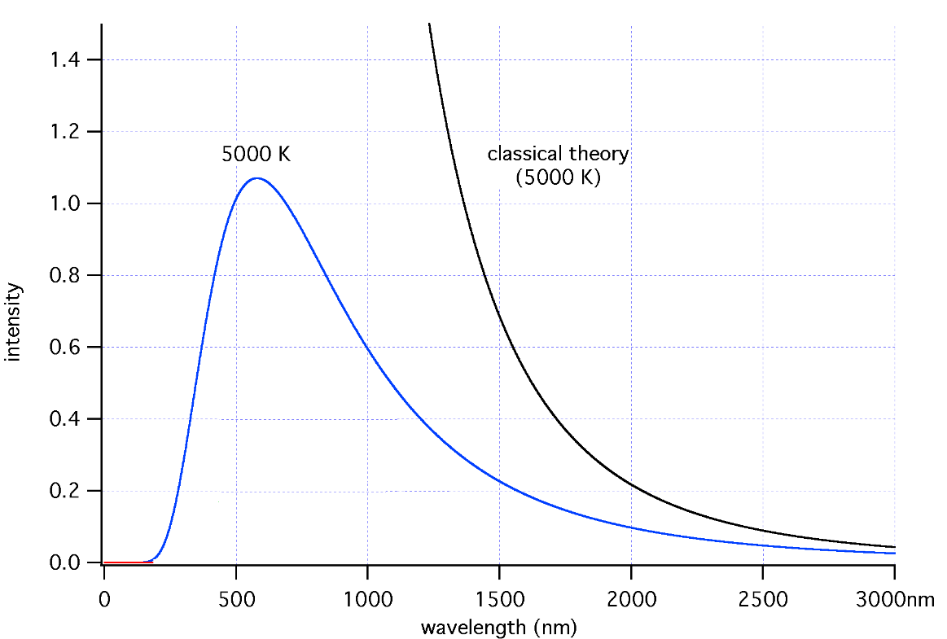

(c) (3 marks)

In reference to black body radiation, what is the Ultraviolet (UV) Catastrophe? What assumption about the nature of light must be made to explain why the actual curve for a black body does not follow that predicted by classical theory?

The **UV catastrophe for a hot black body is**

**that classical (wave) theory predicted that**

**an infinite amount of energy (1)**

**should be released in the UV part of the spectrum. (1)**

**It supports the theory that light acts as a particle (with a quanta of energy) (1)**

**and not as a wave.**

**Question 9**

The figure on the right illustrates some of the valence electron energy levels in a gaseous atom of a particular element. The energies of the levels are given in electron volts (eV).

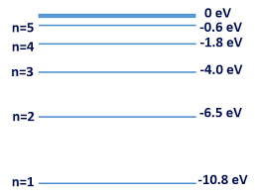

(a) The valence electron of the atom is in the lowest energy level shown. What is the ionisation energy of the atom in joules?

(2 marks)

**Ionisation energy = 10.8 eV (1)**

**= 10.8 x 1.6 x 10-19 J**

**= 1.73 x 10-18 J (1)**

A cold gaseous sample of the element is bombarded by electrons of energy 9.5 eV and observed to emit electromagnetic radiation.

(b) Show on the diagram above the energy level transitions that cause this emission of electromagnetic radiation. (2 marks)

**9.5 eV can excite atoms up to level n = 4 (1)**

**➔ 6 emission lines (1)**

c) Calculate the longest wavelength of the emitted electromagnetic radiation.

**Longest wavelength = smallest energy = 2.2 eV (n = 4 to 3) (1)**

**E = hc/ ➔**

**  = hc/E = (6.63 x 10-34)(3 x 108)/(2.2 x 1.6 x 10-19) (1)**

**= 5.65 x 10-7** **m (1)**

**Question 9**

A 1020 MW electric power station generates electricity at 20.0 kV then steps up the voltage to 5.00 x 102 kV before transmitting the electricity to a city 2.00 x 102 km away. On the edge of the city the high voltage is stepped down through a number of stages before finally being reduced to 240 V for domestic use in homes.

What current is produced by the power station?

$P=VI$

**⇒ $I= \frac{P}{V}= \frac{1020 × {10}^{6}}{20.0 × {10}^{3}}$ (1)**

**= 5.10 x 104 A (1)**

Determine the power lost in transmission if the transmission lines have a total resistance of 4.00Ω.

$P=VI$

**⇒ $I= \frac{P}{V}= \frac{1020 × {10}^{6}}{500 × {10}^{3}}$**

**= 2.04 x 103 A (1)**

**= 1.66 x 107 W (1)**

What is the power delivered to the city?

$P_{city}= P_{total}- P_{lost}$**(1)**

**= 1020 x 106 – 16.7 x 106**

**= 1003 x 106**

**= 1.00 x 109 W. (1)**